* Design a program for accepting decimal number divisible by 2.
* CODE (Divisible by 2) :-

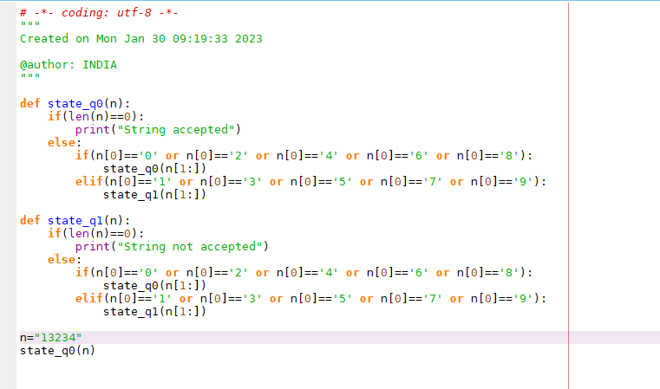

* OUTPUT :

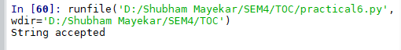

* CODE (Not divisible by 2) :-

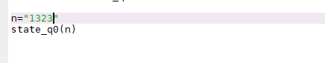

* OUTPUT :-

